Chapter 15, Solution 22.

- Let 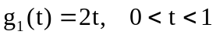
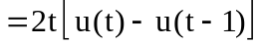

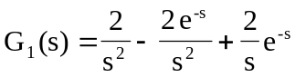

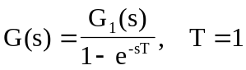

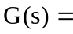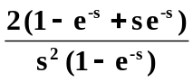

- Let 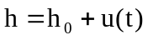, where 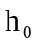 is the periodic triangular wave.

Let 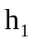 be within its first period, i.e.
